SKILL-8
- To Detect Variable References, Expand Values, Handle Undefined Variables, Update Tokens, Support Nested Variables, Test Expansion Logic.
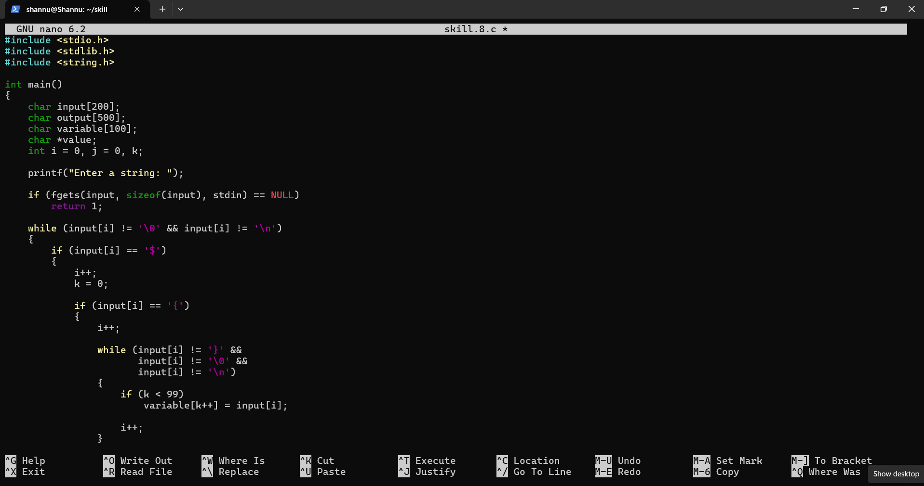
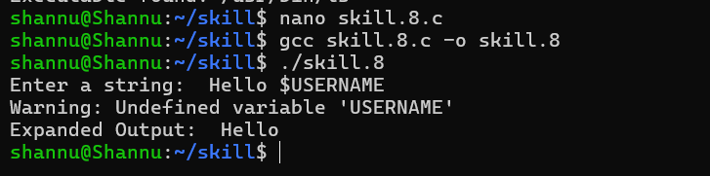
To Identify Built-ins, Create Dispatch Table, Execute In-Process Commands, Handle Invalid Commands, Maintain State, Test Dispatch Logic.
